**WEEK- 1 VIDEO- 10 REPORT**

Understanding import sets:

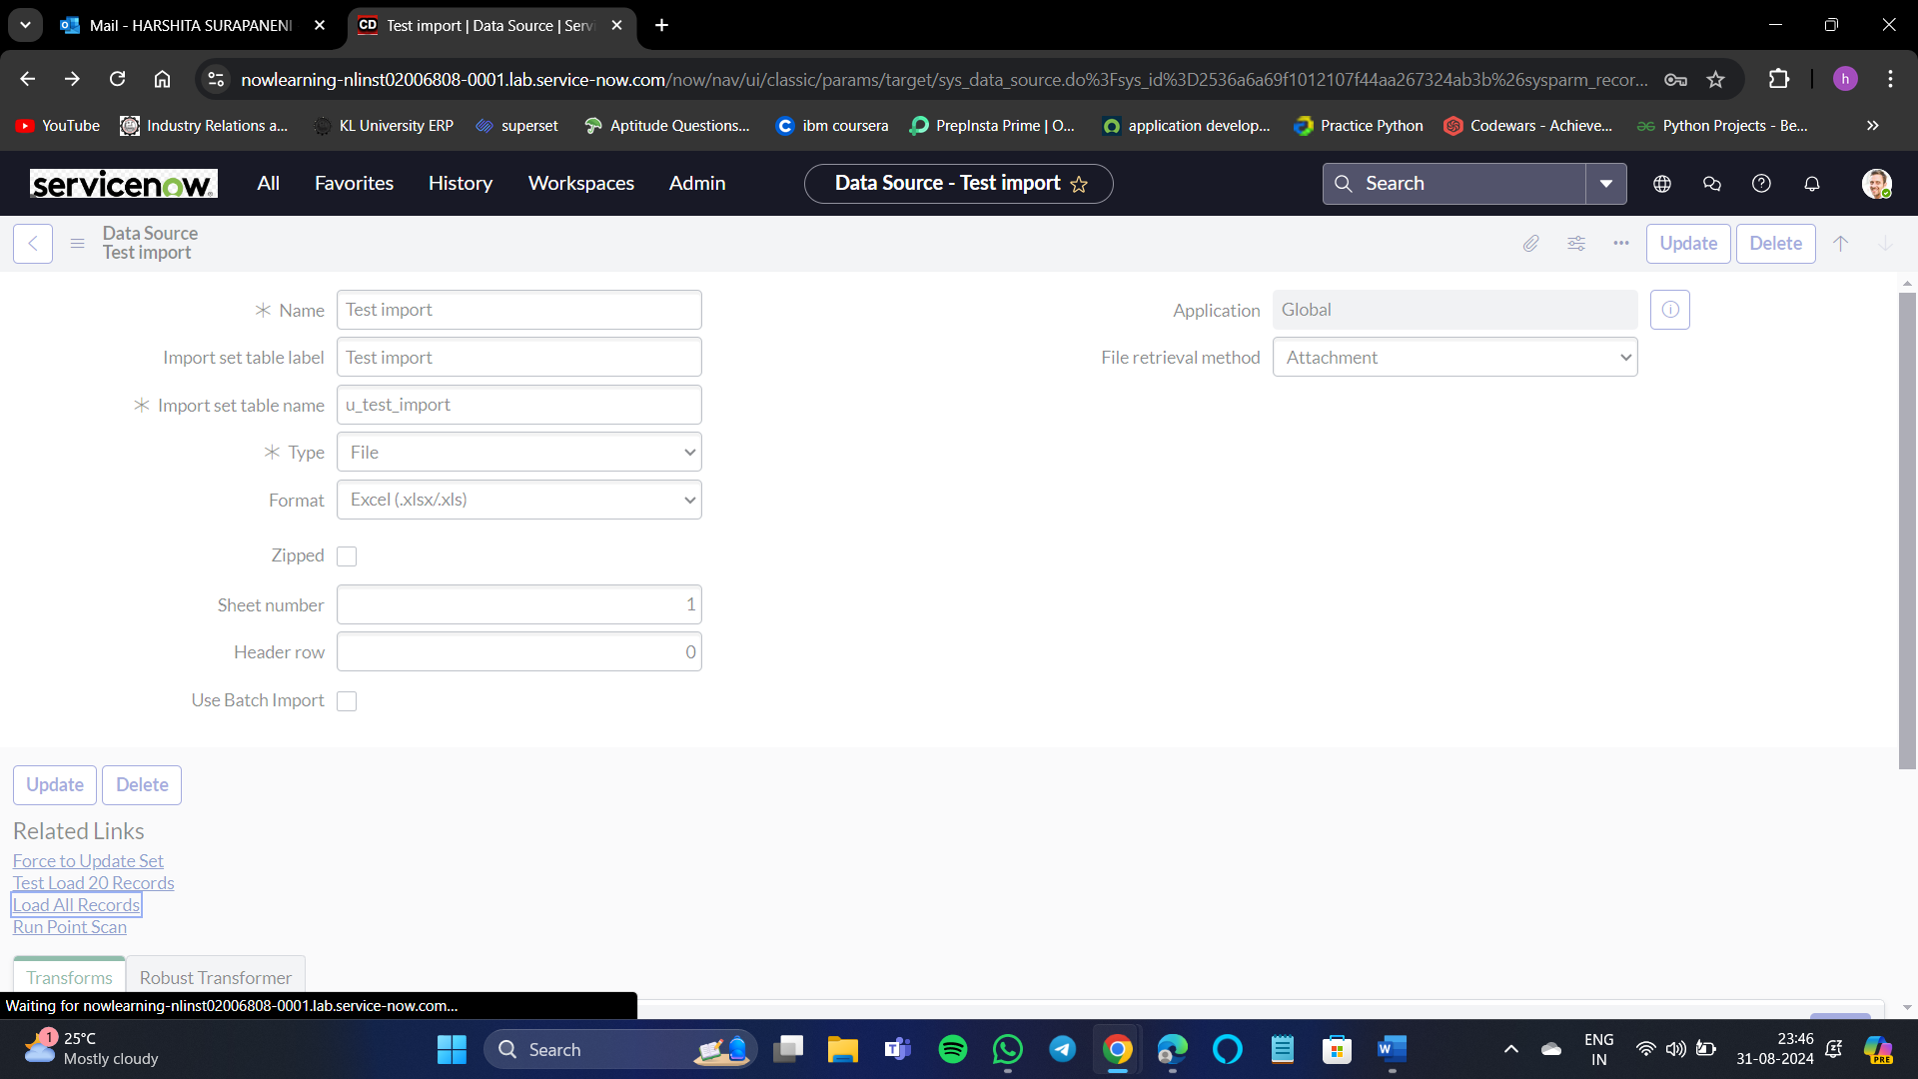

Select all records.

It is showing like this because I have not uploaded any excel sheet after creating this record.

Here, after uploading the Excel document the state is complete and the completion code is success.

To keep the imported records in our staging table organized, ServiceNow provides an out-of-box table named Import Set[sys_import_set]. Each time an import run is executed, the platform adds a record to the import set table. That record represents the import run, or the set of data. As the imported rows are added to the staging table, each record is marked with a reference to the import set record. The Set attribute is used to store that reference. This allows us to organize and identify that our 40 staged records are distributed between 2 import sets.